GAME FOR DYSLEXICS

Final Year Project – Mid Report

Session 2016-2020

A 4th Year Student

A project submitted in partial fulfilment of the

COMSATS University Degree

of

BSc. (Hons.)BS in Computer Science



Department of Computer Science

COMSATS University Islamabad, Lahore Campus

14 May 2020

# Evaluation

|  |  |  |  |  |
| --- | --- | --- | --- | --- |
| **Project Group Members** (To be filled by students) | | | | (To be filled by supervisor) |
| Sr.# | Reg. # | Student Name | *Signature | Obtained Marks  (Total Marks: 10) |
| (i) | FA16-BCS-286 | Noor E Eman |  |  |
| (ii) | FA16-BCS-322 | Nayab Amir |  |  |
| (iii) |  |  |  |  |

*The candidates confirm that the work submitted is their own and appropriate credit has been given where reference has been made to work of others.

Supervisor Name: Dr. Usama Ijaz Bajwa Supervisor Signature: ______________

Remarks (if any): ______________________________________________________________

______________________________________________________________

______________________________________________________________

# Abstract

The present project will be an empirical endeavour for the development of a reliable and valid diagnostic and rehabilitation tool for the children with reading disorder. It is seen that the activity of diagnosis and rehabilitation is boring for the children, consequently being less effective for them. Therefore, to devise a technique through which children learn more is the focus of this project. Children now a days show keen interest in computergames. Due to the proposed tool, which is a series of games, children will be able to differentiate between different sounds, words and letters. This would be done by different techniques and creating different scenarios and levels. This report presents our serious games created to test and train in, different abilities which are usually impaired in subjects with dyslexia. In particular, we primarily test the development of functions, which are deeply related to the children’s future reading skills, i.e., visual search ability, rapid identification of visual and acoustic inputs and the capability to associate visual and auditory stimuli.To this aim, we discuss here a series of serious games, we designed to train specific skills that have been proven to be effective against dyslexia according to Orton Gallium Study.

This game would be a good platform for rehabilitation along with providing the results of performance at the end of game. The game would be developed using unity 3D engine, which provides variety of tools for game creation.

Table of Contents

Abstract 3

1 Chapter : Introduction 8

1.1 Introduction 8

1.2 Motivation and Scope 9

1.3 Goals and Objectives 9

1.4 Problem Statement 10

2 Chapter : Requirements Analysis 11

2.1 Literature Review / Existing System Comparison 11

2.2 Stakeholder’s List 12

2.3 Requirements Elicitation 13

2.3.1 Functional Requirements 13

2.4 Non-Functional Requirements 15

2.4.1 Usability: 15

2.4.2 Response time: 15

2.4.3 Maintainability: 15

2.5 Use case Description 15

2.5.1 Main Menu: 15

2.6 Use Case Design 17

2.7 Software Development Life Cycle Model: 18

3 Chapter : System Testing 20

3.1 Work Breakdown Structure (WBS) 20

3.2 Sequence Diagram 21

3.3 Software Architecture 22

3.4 Class Diagram 23

3.5 Network Diagram (Gantt chart) 24

3.6 Tools and Technologies 25

4 Chapter: System Testing 27

4.1 Unit Testing 27

4.2 Integration Testing 29

4.3 System Testing 29

4.4 Acceptance Testing 29

5 Chapter : Conclusion 30

5.1 Problems Faced and Lessons Learned 30

5.2 Summary 31

5.3 Future Work 31

6 References 33

**List of Tables**

**Table 2.1: Sign up** 13

**Table 2.2: Game basics** 13

**Table 2.3: Score board** 14

**Table 2.4: Time Modes** 14

**Table 3.1: Work Breakdown** 25

**Table 4.1: Test Case 1** 26

**Table 4.2: Test Case 2** 27

**Table of Figures**

**Figure 2.1: Use Case Diagram** 17

**Figure 2.2: Agile Model Diagram** 19

**Figure 3.1: Work Breakdown Diagram** 20

**Figure 3.2: Sequence Diagram** 21

**Figure 3.3: Software Architecture Diagram** 22

**Figure 3.4: Class Diagram** 23

**Figure 3.5: Gantt chart** 24

# Chapter: Introduction

## Introduction

Dyslexia is a neurodevelopment disorder that affects the ability to read, write, spell and speak [1]. Kids with dyslexia often have ordinary vision and are just as smart as their fellows. However, they have to struggle more in school because it takes them longer to read. An individual with dyslexia has difﬁculty with the alphabets, reading comprehension, writing and spelling regardless of adequate intelligence.

Due to the advancement in technology, a recent study [2] shows that dyslexic children trained on action video games learn more quickly than those who learn in classroom environment. Since computer games training has been demonstrated to increment consideration capacities, we explored the impacts of computer games on kids with dyslexia. Reading with computerized (or digital books) and book recordings can enhance a user's learning experience by connecting with them in the substance in multi-tangible ways (e.g., perusing and tuning in simultaneously, perusing along while the digital book highlights each word). Advanced media has been identiﬁed as a promising device to address dyslexic youngsters. The serious video games worldwide expect to connect with users into an activity, which creates a common good or shows something profitable to the player, hiding it into a game. These games help the children with dyslexia to learn and comprehend because games can attract the subject into performing tasks, which helps the therapist in diagnosis of a disease, as well as offering rehabilitation programs.

The goal of this project is to design a rehabilitation tool consisting of strategy-based games. These six strategies use the technical terms to describe the different parts of a word that a dyslexic student will encounter; such as *syllable*, *onset* and *rime, phoneme, blend, grapheme* and so on. We design the storyline of our games using the **Orton Gillingham** techniques. Our basic six strategies in which the game would be mapped are: Sequencing letters, phonics test, count syllables, rapid-atomized naming and rhyming words. Dyslexic children will be trained by playing these games on daily basis as exercises.

We also provide an assessment tool in our game that is helpful in identifying dyslexia in children at pre-school level. The assessment tool is a diagnosis plan to identify whether a child has dyslexia or not. It would also display the reports after playing the games on regularly basis. This tool consists of some questionnaires that will be asked to identify dyslexia. One question regarding each of the above mentioned 6 strategies will be asked so that the game in which the children do perform weak will be trained accordingly.

## Motivation and Scope

Since there are 5 to 10% people who are found to have learning disabilities and this percentage can increase to 17% of total population. Due to this people face hurdles while progressing in life. Their daily functioning in life is affected due to this neurodevelopmental disorder. They lack confidence while communicating and sharing ideas. It is transpired through research that computer games are move affective for dyslexia children than classroom environment. Unlike other related games, in addition to entertaining special children it will work two ways. Firstly, it will provide learning to the children and secondly it would be easier for teachers and parents in diagnosis and rehabilitation. This game will provide attractive interfaces to the children which will help them to remain engaged in the activity. The game’s storylines are created according to the strategies that are described by Orton-Gillingham techniques.

As there is not much work done in this field and all problems cannot be countered in a single game, therefore number of factors should be kept in view before developing such games. Here this game will be targeting the age range of 6 to 12 years disabled children.

## Goals and Objectives

* The main objective of this project is to provide a platform for dyslexic children which improves their reading, writing as well as listening skills.
* Make a serious game for dyslexic children that will help them in the diagnosis of disease and to help them improve their learning skills by playing daily exercises.
* Attract interest of dyslexic children to identify letters and numbers, putting letters and numbers in the correct order and build words with individual letters.
* The game is built on some strategies i.e. finding words by sounds or pictures, identify number of syllables, learn connection between graphemes and phonemes, sequencing letters and other spelling strategies. The purpose of all these training exercises is to make a dyslexic child read and write better.
* **Orton Gillingham** techniques are applied in these games to improve children’s learning abilities. Children will be trained by playing games, these games cover the visual representations of letters that we called graphemes and the distinct units of sound in a specified language that distinguish one word from another, for example *p*, *b*, *d* called phonemes.
* A diagnosis tool is designed in our game that is helpful to identify whether a child is dyslexic or not. This tool contains questions regarding each of the strategies i.e. Sequencing letters, phonics test, count syllables, rhyming words, confusing words and rapid-atomized naming.

## Problem Statement

To build a rehabilitation tool based on game theory, targeting cognitive abilities of subjects having dyslexia for effective leaning and decreasing school dropouts through Orton Gillingham techniques using Unity 3D engine.

# Chapter: Requirements Analysis

## Literature Review / Existing System Comparison

Researchers have been working for differently abled people throughout the world from at least past two decades. There also have been conducted many researches and developed tools for the ease of dyslexic children. Some of the works of people related to this field are as follows.

**ABCya** [3]: it is an online website having number of games for children of different ages targeting some abilities which need to be polished. It works well for all age ranges. It also targets all the abilities lacking in the subject.

**Critical Analysis:** This site having number of games would give definite results, but as it is a website, so it needs continuous internet connection. Secondly there is no way to test whether one has dyslexia or not. It also does not show the progress of subject through time.

**DocLexi** [4]**:** DocLexi is the game especially designed for dyslexic children and is very effective in rehabilitation of disability. It has attractive interfaces as well as daily exercises for the subject, developed by unity 3D but it lacks story and has repetition of tasks. Secondly it does not deal with diagnosis of the disability.

**Eye Games, Dyslexia** [5]**:** It is fun and dynamic, visual learning platform to treat dyslexia. By playing the game the subject matches the similar images. The limitation of the game is that it only checks the visual processing of the subject.

**Critical Analysis:** it only train ones on visual abilities showing graphemes and its matching. It does not cater all the aspects and problems faced by dyslexic children.

**ORT Assess** [6]**:** ORT Assess is an assessment application with black and white interface. It deals with different age ranges. The subject takes the test according to which results are calculated predicting the percentage error. Because of its interface it lacks children’s attention.

**Critical Analysis:** ORT assess is not a game, but a diagnostic tool according to which one knows that if he or she has dyslexia or not. It does not train the abilities which dyslexics need to acquire.

**Lexercise** [7]**:** It is a web-based portal for screening and evaluation of dyslexic people administered by group of therapists, technologists and businessmen. Services are given on payment.

**Critical Analysis:** It has relatively dull interfaces. Children lack interest while using the portal. Secondly it is costly and is not affordable by parents. To use this portal the subject need someone’s assistance.

**Phonics screening check 2012 Technical report** [8]**:** It is standardized and reliable screening checklist for dyslexia used by SLP and Psychologists. It has not been combined with technology and is not accessible by layman.

**Orton-Gillingham** [9]**:** It is an approach targeting reading and writing skills of dyslexics, developed in early 20 century. It is the sequential phonic learning system that teaches word formation. This approach uses three methods of learning i.e. visual, auditory, and kinaesthetic. This approach allows versatility, unlike some programmed and static reading programs.

## Stakeholder’s List

• Developers

o Noor E Eman

o Nayab Amir

• Project Supervisor

o Dr. Usama Ijaz Bajwa

• Beta Testers

• Final Year Project Committee

• Final Year Project Jury

• CUI Lahore

## Requirements Elicitation

### Functional Requirements

**Sign up:**

**Table 2.1: Sign up**

|  |  |  |
| --- | --- | --- |
| **Requirement no** | **Description** | **Priority** |
| REQ-01000 | User will have to sign up so that he would be able to play the game. | 1 |
| REQ-01010 | User have to enter his details to register himself. | 1 |
| REQ-01020 | User have to enter his username and password. | 2 |

Table 2.1 explains the functional requirements of a sign-up page. Three requirements are given with priorities respectively.

**Game Basics:**

**Table 2.2: Game basics**

|  |  |  |
| --- | --- | --- |
| Requirement no | Description | Priority |
| REQ-02000 | The system shall allow a user to be in only one game at the time. | 1 |
| REQ-02010 | The system shall allow a player to exit a game. | 2 |

Table 2.2 gives the description of two functional requirements of game basics with their priorities.

**Scoreboard:**

**Table 2.3: Score board**

|  |  |  |
| --- | --- | --- |
| ID | Requirement | Priority |
| REQ-03000 | The system shall display the number of kills of each object in a game | 3 |
| REQ-03010 | The system shall allow an administrator to set a maximum number of wins to reach before ending the game when creating a game. | 3 |

Table 2.3 describes the functional requirements of score board which will calculate the scores at each level.

**Time Modes:**

**Table 2.4: Time Modes**

|  |  |  |
| --- | --- | --- |
| ID | Requirement | Priority |
| REQ-04000 | The system shall allow an administrator to set a time limit to the game. | 1 |
| REQ-04010 | Player has to complete the task within a given time period in order to win the game. | 2 |
| REQ-04020 | The system shall give a specific time limit in each game level. | 2 |
| REQ-04030 | System shall make a game complex by reducing the time limit to win the game. | 3 |

Table 2.4 explains time mode at each level and its functional requirements.

## Non-Functional Requirements

Non-functional requirements cover the following:

### Usability:

The maximum number of clicks for any function in the system should not exceed five clicks. This can be achieved by usability testing with random users.

### ****Response time:****

The average response time between click and reaction must be less than one second. The maximum response time between click and reaction must be two seconds. Adding some simple classes and methods that will compute and display the time needed to process any operation can test these requirements.

### ****Maintainability:****

The code written for the game must be maintainable. On a design perspective, we will use managed C sharp code in non-performance critical component.  This code will be easier to maintain.

## Use case Description

Use Case descriptions provide a bird’s eye view of how the user will use the system. Use case description of the system is described below:

### Main Menu:

The game consists of main menu interface it contains two options whether the player want to perform testing or training.

#### Rehabilitation: The training interface consists of a set of 6 games that would be created according to some strategies. These 6 games provide daily basis exercise so that a dyslexic child perform better.

The six basic games are as follows:

* **Rapid Naming:** Different pictures are displayed on the screen with its name; player has to identify the picture with its name.
* **Sequencing Letters:** It is used to train a dyslexic child to put the alphabets in a sequence.
* **Rhyming words:** A word is displayed on the screen with the pictures player has to choose the specific rhyming picture in order to win the game.
* **Test phonics:** It is designed to test the phonics. The specific set of phonics would be used in this game to train dyslexic children.
* **Count syllables:** This game is designed to count the number of syllables. Dyslexics has problems to count the syllables, therefore they would have trained by playing this game.
* **Confusing letters:** This game consists of letters that look similar and dyslexics have problem to identify those letters.

#### Diagnosis: It would consist of some questionnaires relating to the upper strategies. One or two questions would be asked from each game to test the disability.

## Use Case Design

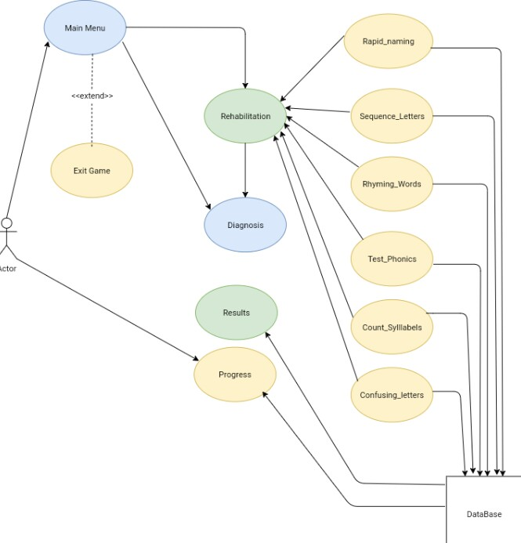



**Figure 2.1: Use Case Diagram**

The main actor in figure 2.1 is the actual player (dyslexic subject). The use case caters two main roles that are rehabilitation and diagnosis, the data of which is stored in database. The second basic role or functionality which is shown in this use case is progress and scores of each game.

## Software Development Life Cycle Model:

The systems development life cycle also referred to as application development life cycle, is used for planning, creating, testing and deploying an information system. There are some most important models of this cycle:

* Waterfall model
* Incremental model
* V-model
* Agile model
* Spiral model
* Big Bang model

**Model Used in our project:**

In our project we used **Agile model** as shown in figure 2.2. It is the basis of iterative prototyping, used for game development. Agile model development depends on feedback and refinement of game's iterations with gradually increasing feature set. Since, agile SDLC model is a combination of iterative and incremental model, which allows developers to deliver working versions of the game in every iteration this approach enables us to have new features, previous features working in better conditions or fixed with every iteration.

**Reason:**

Agile model is effective because in our project we are going to design a game. A popular method of agile software development is **SCRUM**. This will also help us to work individually on each version and module making our work easier and systematic. SCRUM is useful for making games [10].

Using this method, we have following ease

* **Flexibility:**

With the Scrum, we make games from simplicity into complexity.

* **Finding the fun:**

Developers can add the fun in small, iterative doses. Those features that add the most value in terms of fun.

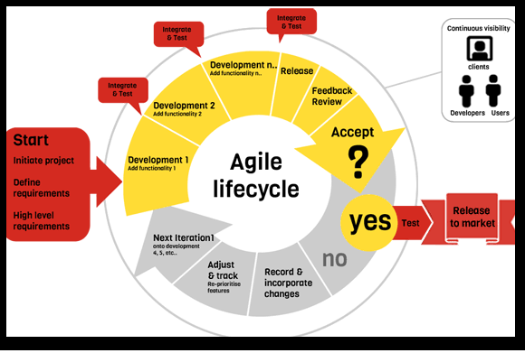**Figure 2.2: Agile Model Diagram**

Figure 2.2 is explaining how agile mode works. The Agile SDLC model combines iterative and incremental process models with an emphasis on process adaptability and customer satisfaction through the quick delivery of the working software product

# Chapter: System Testing

## Work Breakdown Structure (WBS)

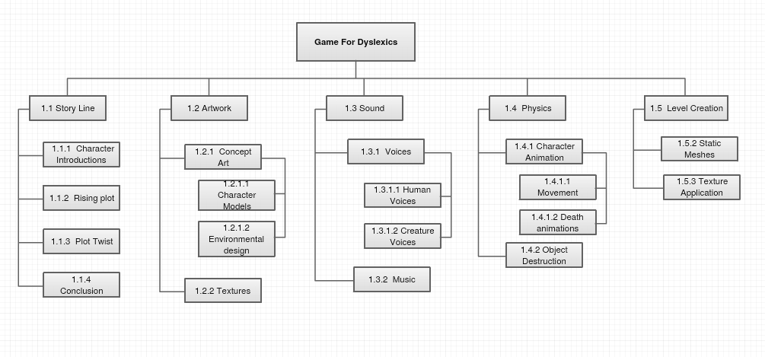

**Figure 3.1: Work Breakdown Diagram**

Figure 3.1 explains the work breakdown structure of the game starting from creating story line until the level creations.

## Sequence Diagram

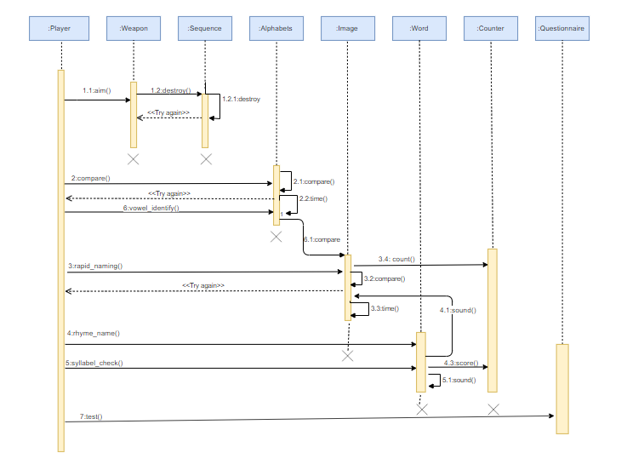

**Figure 3.2: Sequence Diagram**

Figure 3.2 explains a sequence diagram of whole project. A player object can play six games which are given as objects, each game performs its functionality as seen in the diagram.

## Software Architecture

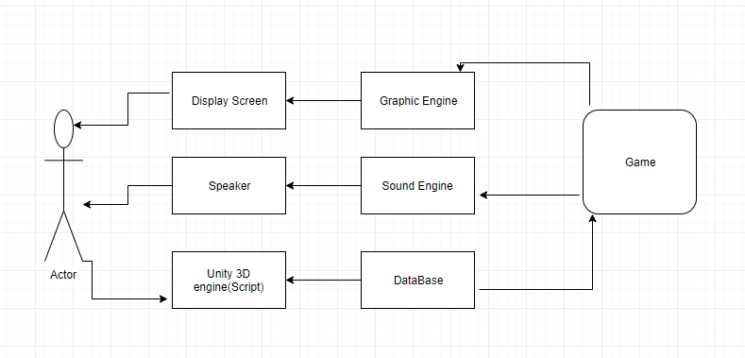

**Figure 3.3: Software Architecture Diagram**

Figure 3.3 explains Software architecture diagram, unity 3d engine is used to build the game. Graphic engine and sound engine are used for graphemes and phonemes process.

## Class Diagram

**Figure 3.4: Class Diagram**

**Figure 3.4** explains project’s class diagram, each class having its methods and variables. The relationships between the classes are also described.

## Network Diagram (Gantt chart)

**Figure 3.5: Gantt chart**

**Figure 3.5** describes each task that can be performed within a specific time period. The starting and ending time for each task is shown in the diagram.

|  |  |  |  |  |  |  |  |  |  |  |
| --- | --- | --- | --- | --- | --- | --- | --- | --- | --- | --- |
|  | **Task 1** | **Task 2** | **Task 3** | **Task 4** | **Task 5** | **Task 6** | **Task 7** | **Task 8** | **Task 9** | **Task 10** |
| **Number of Days** | 30 | 30 | 45 | 30 | 30 | 60 | 15 | 30 | 15 | 30 |

|  |  |  |  |  |
| --- | --- | --- | --- | --- |
| **Sr No.** | **Tasks** | **Start Date** | **Duration** | **End Date** |
| **1** | Requirements gathering,  Research existing games | 17-07-19 | 30 | 17-Aug-19 |
| **2** | Documentation (Sequence diagrams) | 17-Aug-19 | 30 | 17-Sep-19 |
| **3** | 3D environment creation | 17-Sep-19 | 45 | 01-Nov-19 |
| **4** | Characters creation | 17-Oct-19 | 30 | 16-Nov-19 |
| **5** | Objects modeling | 1-Nov-19 | 30 | 1-Dec-19 |
| **6** | Backend Coding | 1-Dec-19 | 60 | 1-Feb-20 |
| **7** | Results calculation | 1-Feb-20 | 15 | 15-Feb-20 |
| **8** | Debugging | 15-Feb-20 | 30 | 15-Mar-20 |
| **9** | Android app conversion | 15-Mar-20 | 15 | 01-Apr-20 |
| **10** | Quality testing | 01-Apr-20 | 30 | 01-May-20 |

**Table 3.1: Work Breakdown**

**Table 3.1** describes work breakdown, starting from requirements gathering until the quality testing. The starting and ending date with the duration time is also mention in the table.

## Tools and Technologies

* **Unity 3D** and other new framework will be used to make the game.
* **Visual studio** will be used for scripting of characters.
* **Unity** **Assets** (tools for human figures) will be used.
* **Terrain tools** (for making hills and tree).
* Design sprites.
* **C sharp language** coding is used to perform the function, actions and movement of the objects in the project.
* Make an **android based application**.
* Connection of **unity to android** so that it can be played on the phone and tablets.

# Chapter: System Testing

## Unit Testing

In this stage, the most fundamental yet most significant segments of the system are tried individually. Unit Testing is the strategy of getting the system's individual units to experience the testing stage. There are frequently devices accessible for unit testing of framework, however for this venture, we'll utilize beta analysers for the issue.

**Test Case 1**

**Unit Name:** Sequence

**Table 4.1: Test Case 1**

**Test Case ID:** Fun_1 **Test Designed by:** Nayab Amir

**Test Priority:** High **Test Designed Date:** 12-Dec-2019

**Test Title:** Sequence letters **Test Executed by:** Noor

**Description:** Order the alphabets in sequence.

**Pre-conditions:**

Player can recognize some of the alphabets.

|  |  |  |  |
| --- | --- | --- | --- |
| **Steps** | **Actions** | **Expected System response** | **Pass/Fail** |
| 1. | Point in the direction of target balloon which is in ordered list. | The balloon will burst and letter will fall in specified bucket. | Pass |
| 2. | Point in the direction of target balloon which is not next in ordered list. | The balloon will bounce back. | Pass |
| 3. | Click on the home button. | Home page will be displayed. | pass |

**Post Conditions:**

player will be able to order the alphabets in sequential manner.

Table 4.1 explains how one of the game modules work that is sequence letters. Its explains what user can do and what can go wrong if not tested. The aim of this game is to place the alphabets in sequence.

**Test Case 2**

**Unit Name:** Rhyming Words

**Table 4.2: Test Case 2**

**Test Case ID:** Fun_2 **Test Designed by:** Nayab Amir

**Test Priority:** High **Test Designed Date:** 12-Dec-2019

**Test Title:** Rhyming Words **Test Executed by:** Noor

**Description:** A word is given with three or more pictures; player has to identify the picture. The selected picture must produce the rhyming sound with the given word.

**Pre-conditions:**

Player can match some of the words with the given pictures.

|  |  |  |  |
| --- | --- | --- | --- |
| **Steps** | **Actions** | **Expected System response** | **Pass/Fail** |
| 1. | Click on sound button so that it would be easy to recognize that particular picture. | The sound button beeps and speaks the particular word with the given picture. | pass |
| 2. | Click on the particular picture, which produces the rhyming sound of the given word. | The picture would be increases in size and highlight with green colour if the user answers is correct. | pass |
| 3. | Click on the home button. | Home page will be displayed. | pass |

**Post Conditions:**

player can understand and learn rhyming words.

Table 4.2 is a test for the rhyming game. At each step if desired response is not generated against desired action then the module would fail to provide its functionality.

**Test Case 3**

**Unit Name:** Count syllable

**Table 4.3 : Test Case 3**

**Test Case ID:** Fun_3 **Test Designed by:** Nayab Amir

**Test Priority:** High **Test Designed Date:** 12-Mar-2020

**Test Title:** count Syllables **Test Executed by:** Noor

**Description:** identifying number of syllables in a word.

**Pre-conditions:**

Player knows what syllables are and vowels sounds.

|  |  |  |  |
| --- | --- | --- | --- |
| **Steps** | **Actions** | **Expected System response** | **Pass/Fail** |
| 1. | Click on the sound button to hear pronunciation of word. | The sound would be played. | Pass |
| 2. | Click on the wrong option out of four given. | A red cross sign will appear indication wrong answer. | Pass |
| 3. | Click on the help button. | Instructions would be given on how to play the game. | pass |

**Post Conditions:**

player will know how to break word into chunks .

Table 4.3 explains how one of the game modules work that is Count Syllables. Its explains what user can do and what can go wrong if not tested. The aim of this game is to make player blend sounds.

**Test Case 4**

**Unit Name:** confusing Alphabets

**Table 4.4: Test Case 4**

**Test Case ID:** Fun_4 **Test Designed by:** Nayab Amir

**Test Priority:** High **Test Designed Date:** 12-Dec-2019

**Test Title:** confusing Alphabets **Test Executed by:** Noor

**Description:** A letter puzzle would be given with mirror letters and player has to search for the pair of the letter. .

**Pre-conditions:**

Player have good visual memory.

|  |  |  |  |
| --- | --- | --- | --- |
| **Steps** | **Actions** | **Expected System response** | **Pass/Fail** |
| 1. | Click on one of the card. | Card will face towards player. | pass |
| 2. | Click on the particular picture, which produces the rhyming sound of the given word. | The picture would be increases in size and highlight with green colour if the user answers is correct. | pass |
| 3. | Click on the progress button. | Progress of player will be displayed will be displayed. | pass |

**Post Conditions:**

player will different between mixing alphabets.

Table 4.4 is a test for the confusion letters. At each step player will memorize the different shapes of letters.

## Integration Testing

After unit testing, the positively classified tests provide the group of units to form a functional module. These modules are then combined together to perform logical actions in the game and this procedure is known as Integration Testing.

## System Testing

After the previous two assessments, system testing is performed, in which the complete system / game, is tested for any errors, lack of functionality or any negative classification against the standards set by the requirements analysis in the requirements phase. These end to end experiments are part of black box testing and this whole phenomenon is known as System Testing.

## Acceptance Testing

Evaluating whether, the given system is compliant with the essentials and requirements for the final debut of the system / game, is known as acceptance testing. The system’s performance is also analysed, and it is checked if the objectives are actually met or not.

# Chapter: Conclusion

## Problems Faced and Lessons Learned

Having to decide for a Final Year Project such as this is a huge challenge itself. A game development project is usually done by a gaming studio where for each task, they have proper teams of professionals set up, such as a team of professional animators, the rigging/ modelling team, the networking team, the design department, the programming sector, etc. Hence, doing all the stuff without high tier equipment and being a two-man team for the whole thing is a huge step taken in the deepest pit of challenges and obstacles.

The concept of designing a basic game seemed a little more of simple to us, but as we started the project, the phases to go through before the completion were very much unconsidered prior to initializing the project. The modules, mostly of which were known to us, were very technical as to how to apply them in the game itself.

The very first issue encountered was, where to begin. It was imperative to lay down a groundwork upon which we would start building the structure of the game, but it was very confusing to decide whether to start by creating 3D character models, design the environment first, or start with programming and networking etc.

Another issue that came across our paths was the project scope. It was much easier to just set a scope on par with the games designed by studios on industry level, but as we progressed, we had to narrow down the scope to a scale that would be viable for us to accomplish within our limited time and resources.

Setting up a proper content for the game and a campaign storyline to follow was another hurdle which was not only time taking to formulate but also to document and explain to the stakeholders.

For testing, beta testers were not available, so having to find suitable beta testers for the test phases of the game was also a challenge in on itself.

The biggest issue with the development was to learn various software for every individual task upon which in a game-dev studio, a whole team presides. E.g. learning software for modelling, rigging, animation, texturing, shading, etc. Bottom-line, the main challenge of this project is being the one-man army to develop a game that meets the standards on the Industrial Scale.

However, the by-products of these challenges were resultant in our learning, and enhancing our skills to another significant level, honing our management abilities on a whole new extent.

## Summary

This project is research and development based. A thorough research was done before the project is created. The concept of designing a basic game seemed a little more of simple to us, but as we started the project, the phases to go through before the completion were very much unconsidered prior to initializing the project. The modules, mostly of which were known to us, were very technical as to how to apply them in the game itself.

## Future Work

The future endeavours for this project have an endless scope in the modern era of gaming and entertainment. This project is developed under a specific age limit (6-12) of children having dyslexia. The Game can be designed for people of different ages i.e. kindergarten, grade1, grade2 and so on. This can help people to control and improve their disability by the advancement of the technology. In this project we make a diagnosis and training tool that may not cover all the types of dyslexia.

* Phonological **Dyslexia**.
* Surface **Dyslexia**.
* Rapid Automatic Naming **Dyslexia**.
* Double Deficit **Dyslexia**.
* Dyscalculia.
* Dysgraphia.
* Left Right Confusion.

The future work for this project is that we can work on different types of dyslexia and make children learn better. Symptoms can vary, but in many cases a person may have difficulty remembering and organizing numbers, or they may have trouble telling time. As with dyslexia, individuals may avoid situations where math may be involved.

Other symptoms may include difficulty with:

* Word problems
* Carrying and borrowing numbers
* Managing money

In future the game levels can be extended if we design the levels on mathematical dyslexia describe above. Our future work may consist the following:

* Level Extensions on different types of dyslexia.
* Improve graphical representation in unity 3D environment.
* Introduce new game features.
* Introduce new environments and scenes.

# References

|  |  |
| --- | --- |
| [1] | “International Dyslexia Assoiciation,” [Online]. Available: https://dyslexiaida.org/definition-of-dyslexia/. [Accessed 22 Nov 2019]. |
| [2] | “Video game development,” wikipedia, [Online]. Available: http://en.wikipedia.org/wiki/Video_game_development. [Accessed 28 Nov 2019]. |
| [3] | “Abcya,” [Online]. Available: https://www.abcya.com/. [Accessed 11 Nov 2019]. |
| [4] | *DocLexi: learn to Read &Spell,* Munich: BBG Entertainment, 2018. |
| [5] | P. developers, *Eye games, Dyslexia,* PMQ software, 2016. |
| [6] | Mojility, *ORT Assess, Dyslexia Reading Test,* Chicago: Mojility Inc., 2014. |
| [7] | S. B. Blackley, “Lexercise,” 2008. [Online]. Available: https://www.lexercise.com/. [Accessed 28 july 2019]. |
| [8] | “Phonics screening check 2012 technical report,” Standards and testing agency, 2012. |
| [9] | “Academy of Orton-Gillingham Practitioners and Educators,” [Online]. Available: https://www.ortonacademy.org/resources/what-is-the-orton-gillingham-approach/. [Accessed 25 november 2019]. |
| [10] | M. Cohn, “mountain goat software,” [Online]. Available: https://www.mountaingoatsoftware.com/presentations/agile-and-scrum-for-video-game-development. [Accessed 2 Dec 2019]. |

